First draft: Chinese construction, urban engineering and megastructure stakeholders in Laos

Table des matières

Introduction to the BRI 2

Historical review, from the old silk road to the new one 2

The political outcomes of the BRI 3

The Belt and Road Initiative and its stakes in South-East Asia 4

The global plan in South-East Asia 4

Implications in Laos region 5

# Introduction to the BRI

## Historical review, from the old silk road to the new one

Chinese trade outreach has been known to us for over 2 millennia. The historical Silk Road has been a trade network connecting the east of Asia to the central part of the Eurasian continent. Two hundred years B.C., during its heyday with the Roman and Byzantine governance, and until their fall to the sea routes, these roads connected two geographical extremes **(McBride, 2015)**. These roads gathered together different civilizations as never before. It was not only gold, silk or spices that were traded in the markets along the route, but also knowledge, thought and technology. The power associated with its control and thus its security has shaped an infrastructure commensurate with its importance. The Great Wall of China being the best example[1].

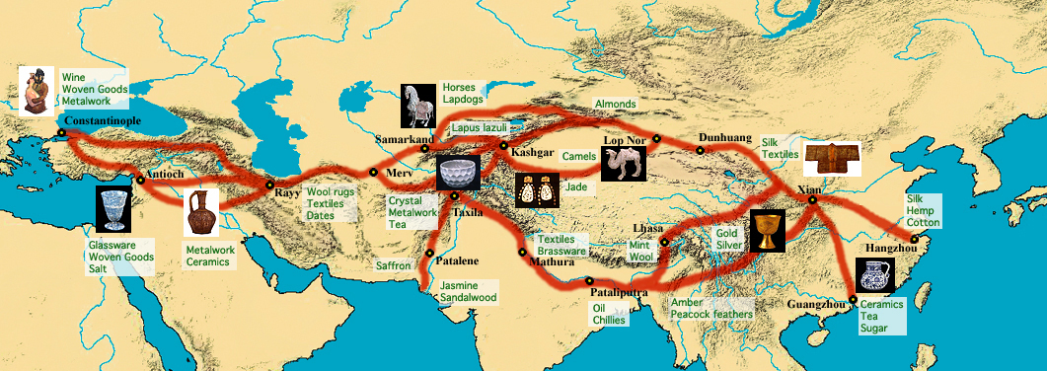

Figure 1 - Map of silk routes[2]

Despite the existence of older routes, we can trace the birth of the Silk Roads to around 130 BC and the sending of an ambassador from the Han dynasty for political and military reasons. It was on his return that he proposed the idea of opening up trade with the regions he had visited, suggesting the economic expansion of the Chinese empire.

On 7 September 2013, the Chinese President delivers a speech at Nazarbayev in Kazakhstan. In what appears to be a response to the 2008 economic crisis **(Apostolopoulou, 2021)**, he sells an economic stimulus that will support the creation of new infrastructure: railways, energy pipelines, highways and streamlined border crossing **(McBride, 2015)** that will be known as the “Silk Road Economic Belt”. One month after at the Indonesian parliament, the Chinese president also introduced the “Maritime Silk Road”, another infrastructure development around maritime trade along the Asia-Pacific coast, the Indian Ocean to the Mediterranean Sea.

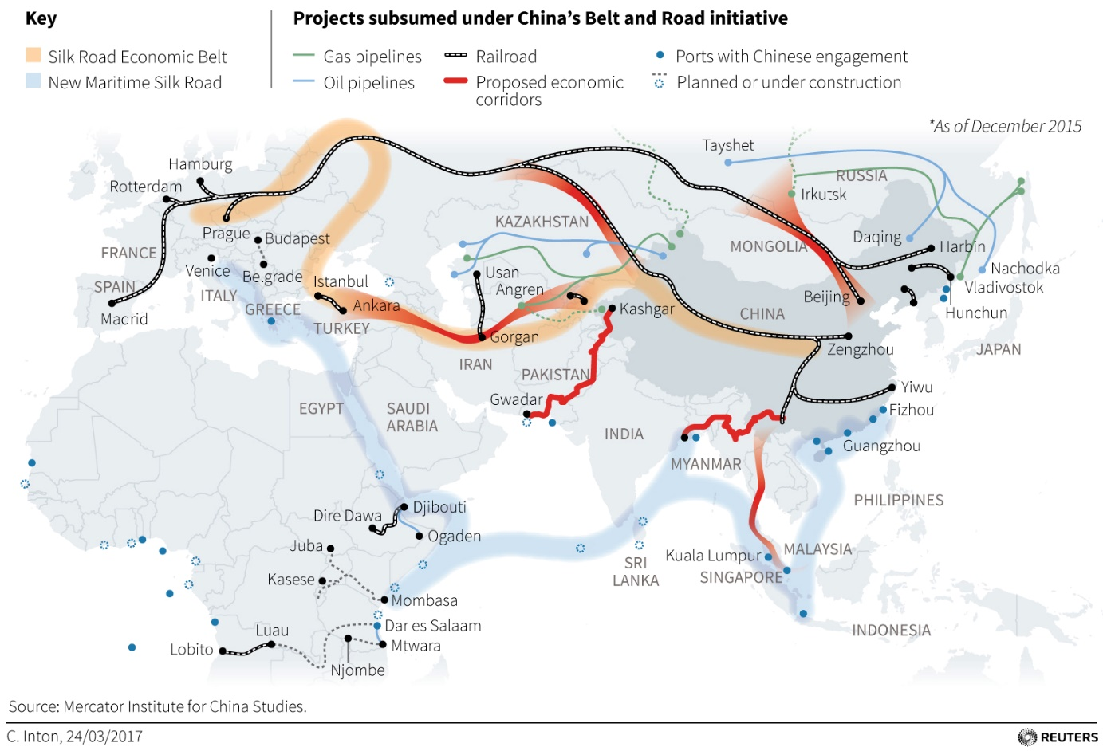

Figure 2 - Map of the routes developed in the scope of the "Silk Road Economic Belt" and the "Maritime Silk Road"[3]

It is geographical and political similarities that bring the old and new Silk Roads together. However, the development of these two trade routes is rather different. Where the Silk Road created new urban areas along its route, the Belt and Road Initiative creates new urban areas in order to create this route. In the same way, the Silk Road promoted the creation of multi-cultural cities, whereas the BRI seems to repeat the development of the Chinese model and tends towards a uniformity of spaces **(Otmakhova, 2018)**.

## The political outcomes of the BRI

As the title of Xi Jinping's speech informs us: “Promote people-to-people friendship and create a better future”, the Chinese government emphasises the win-win and collaborative strategy of the New Silk Road. However, this strategy remains unclear and without an official road map, China is free to add new project to the official BRI and remain agile in its decisions and political identity **(Narins, 2020)**. In addition, the literature reviewed in this report repeatedly reports the current lack of research depicting a qualitative analysis or retrospective of Chinese actions in building the BRI **(Apostolopoulou, 2021)**, **(Urban, 2013)**. This leaves us with a very blurry vision of the past and future evolution of the project.

Despite an often engaged literature and the distance I have taken from it, it is impossible not to consider the China's geopolitical reinforcement on the countries targeted by the BRI. The BRI is, of course, an infrastructure development but while promoting its the economic impact and its support for growth, Beijing is also introducing a form of soft power. Moreover, some regions are instable in terms of geo-politics and security which contrast with the current people-to-people discourse **(Sharma, 2019)**. Especially since the BRI will involve sixty-nine countries, that represent 60% of the global population. We can only acknowledge the challenge of bringing together disconnected policies around a common project with the requirement to break down many spatial barriers.

|  |  |  |  |  |  |
| --- | --- | --- | --- | --- | --- |
|  | **Politico-economic** | | | **Physical** | **Socio-cultural** |
| *BRI GOALS* | *Financial integration* | *Unimpeded trade* | *Policy coordination* | *Connectivity* | *People to people bonds* |
| BRI INSTRUMENTS | Capital loans, technical financial tools | Economic cooridors, trading agreement | Diplomatic agreement, policy programmes | Nodal infrastructures, roads, railways, ports, airports, telecommunications networks, pipelines, development zones and cities | Silk road cultural legacy, educational programmes, Chinese culture institutes |
| Special Economic Zones | |

To carry out the development of the project, the Chinese state uses a range of tools. According to **(Otmakhova, 2018)** we can sort them into three different categories. First of all, the political and economic ones, which make it possible to set up governance in trade. We then speak of investment, political or economic agreement. The so-called "physical" or "socio-economic" tools correspond to the realities on the ground and the results we can observe and will analyse in this report. It is more a question of the Chinese cultural-spatial legitimacy concerning regional trade and the technical know-how for the construction of such large infrastructures.

Table summarising the goals and tools of the BRI (by Otmakhova)

# The Belt and Road Initiative and its stakes in South-East Asia

## The global plan in South-East Asia

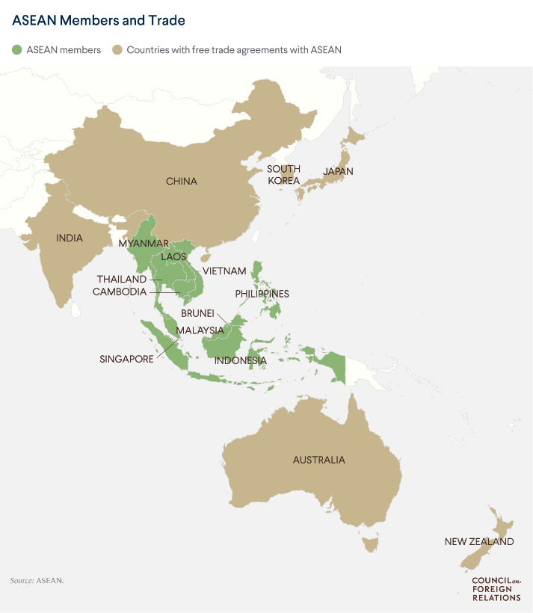

The BIS is organising in South East Asia along the China-Indochina Peninsula Economic Corridor (CICPEC). It is the link between the countryside and the sea, a passageway to the southern seas and at the end of its development, it will be a much faster alternative to sea transport **(Mottet, 2018)**. This corridor involves the ten members of the Association of Southeast Asia Nation (ASEAN). Within this group, Laos occupies a central position with the so-called China Laos Economic Corridor. And it is thanks to the development of an express railway, a key project in the development of the BRI, that Laos will connect the Chinese province of Yunnan to the rest of ASEAN.

This economic development project allows countries to enjoy many benefits. Firstly, the BRI helps to reduce the development gap by providing access to better infrastructure. In addition to BIS construction, there are also initiatives related to health and education. The installation of the BRI has also pushed digitisation in some lagging countries. Finally, these economic expansions are pushing countries like Laos, Vietnam, Thailand and Indonesia to have a very strong urbanisation.

Figure 3 - Map of the ASEAN members and trade allies

There are joint initiatives between these countries such as the ASEAN Smart Cities Network and the ASEAN Sustainable Strategy. China is obviously the natural partner as a leader in smart city technologies.

This Chinese presence also remains a risk in terms of geopolitics, security and governance and could in the future upset the balance of power in this region of the world, as is already the case with maritime tensions in the South China Sea. **(Rana, 2020)**

## Implications in Laos region

The country of Laos with which we are currently familiar, the Lao People's Democratic Republic, is relatively new as it was founded in 1975. It is a small country of 7 million people with no sea coast and historically the country has been very little impacted by colonialist policy unlike its neighbours like Vietnam or Thailand. Despite the transition from socialist planned economy to market economy in 1986 with the policies of the New Economic Mechanism, it is since the arrival of the BIS that we have seen an explosion in the number of investments by China in the state of Laos **(Chen, 2020)**. We have already mentioned the strategic location of the country within the elaboration of the economic corridor but Laos also represents according to **(Lu, 2019)** "an archetypal target country for investment" due to its abundance of natural resources, its poor governance of the territory and the fact that it is still an under-developed country.

Economically and politically wise, China arrived in the middle of the rivalry between Thailand and Vietnam over the exploitation of Laos. And this first one, according to **(Mottet, 2018)**, seems to benefit from a capital of sympathy, with the youngest Laotian leaders in particular, and with the urban population in general. However, Laos does not seem to be without ambition and the country remains aware of the importance of its strategic position in the Chinese plans and more globally in the economic development of Southeast Asia. It is also reported that the country allows itself to maintain a certain degree of independence from its powerful neighbours and that China, if it does not succeed in establishing itself in a sustainable manner while avoiding its image as an invader, could see its influence stagnate or even decrease.

A position that China seems to find difficult to follow. Indeed, the first impacts of the BRI are already very visible and the arrival of mega-infrastructures has increased some social and environmental problems. First of all, the mountainous landscape so characteristic of this part of the world is changing and becoming more and more concrete **(Chen, 2020)**. As a result, concerns arise regarding environmental preservation: for example, mining and construction in originally protected national parks or hydroelectric constructions altering river ecosystems **(DiCarlo, 2017)**. And from a social point of view, the presence of Chinese infrastructures is becoming more and more noticeable in view of the numerous relocations of populations **(DiCarlo, 2020)**.

1. Xinru, Liu (2010). The Silk Road in World History New York: Oxford University Press, p. 11
2. https://95698391.weebly.com/historical-context.html
3. http://www.datajournalism.it/la-mappa-della-nuova-via-della-seta/